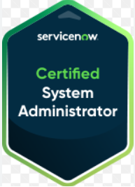 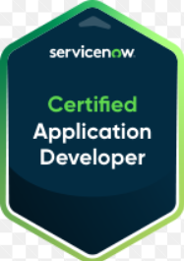  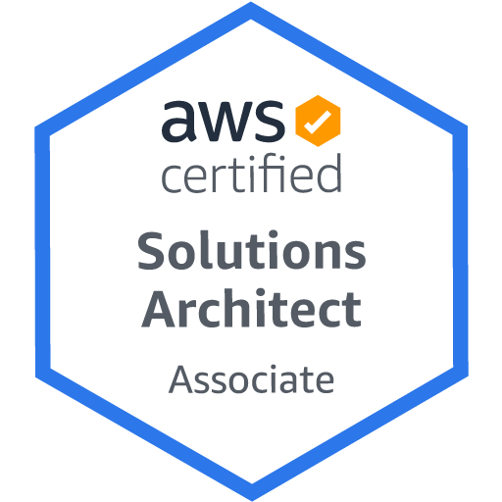 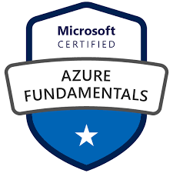 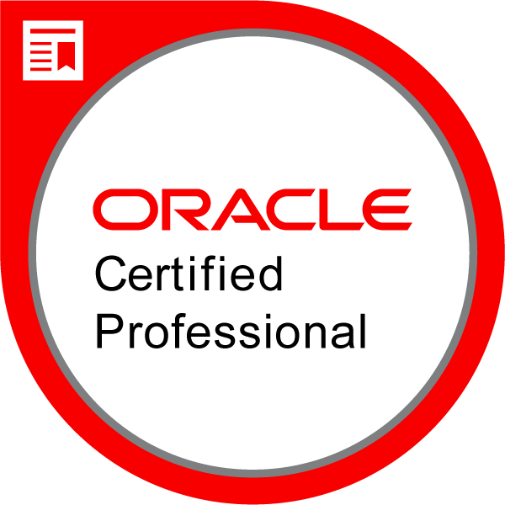 _________________________________________________________________________________________________

Natti
(678) 799 9678 | John@concept-inc.com

Professional Summary
ServiceNow Certified Technical Lead and Senior Enterprise Platform Engineer with extensive experience delivering ITSM, CMDB, discovery, integrations, and platform modernization initiatives within large-scale banking and enterprise environments.

- Proven expertise leading ServiceNow upgrades, instance migrations, environment cloning, and release readiness activities, ensuring smooth transitions with minimal disruption to business operations.
- Experienced in ServiceNow Virtual Agent design, Integration Hub configuration, and external system connectivity, enabling intelligent self-service and automated data exchange across enterprise platforms.
- Skilled in building and maintaining Script Includes, reusable server-side libraries, and import set/transform map frameworks to standardize data ingestion pipelines and reduce development overhead.
- Demonstrated ability to support end-to-end ServiceNow lifecycle management, including requirement analysis, solution design, development coordination, testing support, deployment validation, and post-production stabilization.
- Skilled in designing and implementing ServiceNow automation workflows, catalog solutions, and ticket lifecycle improvements to streamline processes and reduce manual operational effort.
- Strong experience managing production incidents, platform troubleshooting, and performance issues, ensuring round-the-clock ServiceNow availability for enterprise users.
- Demonstrated expertise in platform governance and release coordination, partnering with change management and security teams to enforce deployment standards, manage blackout periods, and ensure zero-defect releases across enterprise environments.
- Track record of supporting enterprise-scale environment cloning, instance refresh cycles, and pre-production validation, ensuring development and testing teams have stable, integration-verified environments on demand.
- Proven ability to manage privileged access governance, CyberArk onboarding, and ACL-based security controls within ServiceNow, ensuring alignment with enterprise security policies and audit requirements.
- Demonstrated strength collaborating with business stakeholders, infrastructure teams, architects, and external vendors, translating functional requirements into scalable technical implementations.
- Known for mentoring team members, guiding offshore resources, and acting as a technical escalation point for complex ServiceNow platform issues.
- Strong communicator with a consistent track record of delivering stable, scalable, and business-aligned ServiceNow solutions in fast-paced enterprise environments.
Core Competencies
ServiceNow Platform Engineering • ITSM Implementation & Administration • CMDB Governance & Discovery Architecture Instance Upgrades & Release Management • MID Server Configuration • Workflow & Catalog Automation JavaScript Customization (Business Rules, Client Scripts, Background Scripts) • Production Incident Resolution • Environment Cloning & Deployment Coordination • Audit & Security Compliance Support
Integration Validation & Platform Troubleshooting • Stakeholder Collaboration & Technical Leadership
Enterprise Change Management Support • Disaster Recovery Readiness • Process Optimization & Documentation

Technical Skills
ServiceNow Platform: ITSM (Incident, Problem, Change, Request), CMDB, Discovery, MID Server, Flow Designer, Catalog, Reporting, ACLs, upgrades, cloning, integrations, platform scripting
Development / Scripting: JavaScript, ServiceNow background scripts, business rules, client scripts, workflow configuration, REST integrations, PowerShell basics
Cloud & Infrastructure Exposure: AWS fundamentals (EC2, S3, IAM), Oracle Cloud Infrastructure (OCI), Microsoft Azure fundamentals
Operating Systems: Windows Server, Linux/Unix environments, RHEL exposure
Tools & Platforms: ServiceNow Studio, Update Sets, Postman, Jira, Git, enterprise monitoring tools
Enterprise Practices: Agile/Scrum collaboration, change management processes, audit remediation support, documentation and release validation

Certifications
- ServiceNow Certified Administrator – Zurich (Credential ID: 26637412)
- ServiceNow Certified Application Developer (Credential ID: 24364623)
- ITIL: ITIL V3/V4 Certified (Credential ID: 00087687)
- AWS certified Solutions Architect Associate (Credential ID: AWS01029365)
- Microsoft Azure Fundamentals Certified (Credential ID: MS0990545110)
- Oracle Cloud Infrastructure Certified Architect Professional (Credential ID: OC0971925)
Professional Experience
PNC Bank - Birmingham, AL Sep 2020 – Present
ServiceNow Application Technical Lead (CTB)

- Served as Technical Lead for the ServiceNow Mnemonic platform, owning platform stability, infrastructure coordination, and enterprise operational readiness across global environments
- Led RHEL 7 → RHEL 8 platform migration, coordinating proxy rebuilds, validation cycles, and access restoration, ensuring seamless transition without business interruption
- Delivered key enterprise initiatives including City Plan Move execution and BigPanda Integration stabilization, strengthening monitoring reliability and operational visibility
- Implemented global MID Server deployments using PowerShell automation, standardizing build processes and improving onboarding efficiency for new infrastructure regions
- Supported Evolven Drift Management readiness, validating environment configurations and assisting governance teams with certification requirements
- Managed CyberArk privileged account onboarding, improving credential governance and aligning ServiceNow access controls with enterprise security policies
- Executed large-scale instance cloning cycles, coordinating refresh schedules, validating integrations, and ensuring environment usability for development and testing teams
- Played a key role in BCX disaster recovery simulations, validating environment accessibility and confirming recovery success criteria
- Closed audit remediation items and compliance tasks, preventing operational change blackouts and maintaining platform governance continuity
- Delivered post-release production stabilization, resolving defects, config issues following deployments
- Contributed to technical documentation and operational runbooks, improving repeatability for cloning, upgrade readiness, and troubleshooting processes
Environment: ServiceNow ITSM, CMDB, Discovery, MID Server, JavaScript, Flow Designer, Instance Cloning, Upgrade Management, CyberArk, REST APIs, Windows, RHEL 7/8, AWS, Jira, Git

BBVA USA – Birmingham, AL Oct 2012 – Sep 2020
ServiceNow Developer / Platform Administrator

• Administered and developed within the ServiceNow platform supporting ITSM modules (Incident, Problem, Change, Request) across a large-scale banking environment, ensuring platform reliability and service continuity
• Engineered and maintained Script Includes and reusable server-side utility libraries to centralize business logic, reduce code duplication, and improve platform maintainability across teams
• Worked on enterprise integrations LDAP directory sync, SSO configuration, and Jenkins-based deployment pipelines connecting ServiceNow with identity management, access provisioning, and release automation
• Designed and deployed REST-based outbound integrations connecting ServiceNow with external banking and monitoring platforms, leveraging Integration Hub spokes and scripted REST messages to automate data exchange
• Contributed to the rollout of Virtual Agent and chatbot capabilities on the ServiceNow platform, configuring conversation flows and topic blocks for common IT requests in the banking environment
• Developed and tuned Business Rules, Client Scripts, UI Policies, and ACLs to enforce data integrity, drive form behavior, and apply role-based access governance across ITSM workflows
• Built Service Catalog items and Flow Designer automation workflows to streamline IT request fulfillment, enabling end-users to submit and track requests without manual intervention from support teams
• Managed import sets, transform maps, and scheduled data jobs to synchronize data between ServiceNow and external enterprise systems, maintaining CMDB currency and supporting audit compliance requirements
• Supported ServiceNow upgrade cycles and update set migrations across environments, performing conflict analysis, regression validation, and post-upgrade stabilization to preserve customizations and business functionality

Leadership Highlights
• Acted in Product Owner capacity for BBVA’s Fraud Detection application (Detica), collaborating with BAE Systems and internal stakeholders to prioritize features and deliver platform improvements
• Served as Single Point of Contact for Bank Trade / Client Trade Systems, coordinating with BT Systems vendor and internal teams to ensure successful delivery, issue resolution, and production stability

Environment: ServiceNow ITSM, CMDB, Discovery, MID Server, Virtual Agent, Integration Hub, Script Includes, Flow Designer, REST APIs, JavaScript, Update Sets, RHEL, Oracle DB, UNIX Shell

CMA Systems (CMA CGM Group) — Dubai, UAE Aug 2007 – Aug 2012
Senior Oracle Database Administrator

• Managed core Oracle DBA activities in a 24×7 onshore-offshore support model
• Led international migration initiative coordinating design, build, testing, cutover, and post-go-live stabilization with onsite teams in France
• Installed, configured, and administered Oracle databases across 10g and 11g environments

Environment: Oracle 11g/10g, RAC, RMAN, Data Guard, SharePlex, GoldenGate, OEM, AIX, RHEL, TOAD

CMA CGM ITTA — Chennai, India Mar 2007 – Aug 2007
Junior Application Developer

• Developed Oracle Forms/Reports solutions and SQL/PLSQL modules for enterprise ERP systems

SRF Technology Centre — Chennai, India Aug 2006 – Mar 2007
Programmer Trainee

• Developed PL/SQL packages, procedures, triggers, and audit logic

EDUCATION
Bachelor of Engineering | JNTU, India | 2002-2006

